Assignment 1

Report

(Gurvi Singh)

(S-345823)

**Introduction**:

The objective is to write a program for creating Scrabble word game using TDD and automated testing tool. For this task, an excellent programming language and automated testing tool is required. There is a need for creating the test cases first, then running the tests. If the tests pass, then there is need to complete the code in a flow, if the tests fail, there is need to do changes in the code.

I will be using Python programming language because it is a high level programming language with many important features like user-friendliness, vast libraries support, portability, etc. It is very easy to use.

For TDD, I shall be using Pytest as the automated testing tool for testing the program. Pytest makes it safer and easier to refactor the code by putting tests into place through which refactoring occurs without problems and disruption. It has more features as compared to the other testing tools. It’s like doing quality assurance of the code. It is also easy to use.

**Process**:

Pytest tool is used to first create the test cases. These test cases are run one by one. On passing of the test cases, the program code is made further. The whole program is divided into separate functions so that these can be tested easily and if there is failure, then the code can be edited.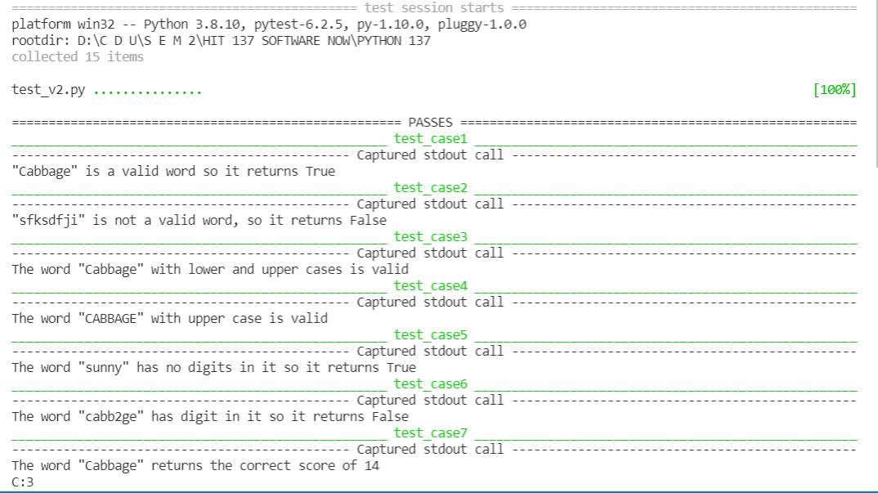

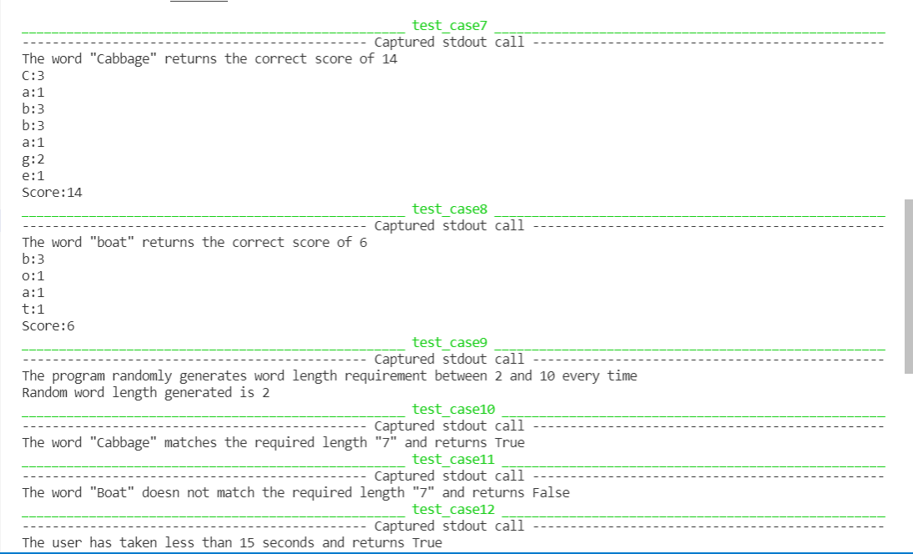

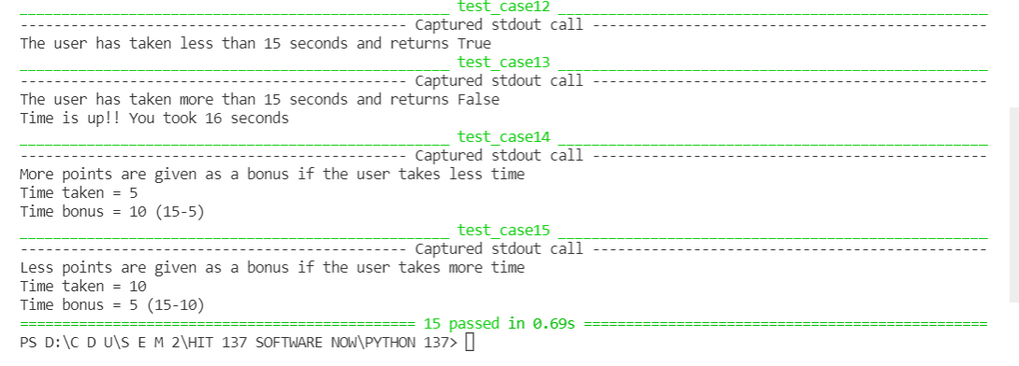

**Conclusion**:

When working with pytest testing tool, the tests failed quite a lot of times and the code was edited multiple times till the tests got passed in the terminal. Pytesting makes it really easy to isolate and fix the issues very well. In the future, I shall continue using this wonderful tool with more confidence and interest. I found this tool quite useful.

Github link:

https://github.com/Gurvisingh111/Scrabble